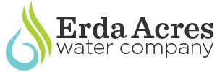 P.O. Box 11, Tooele UT 84074
www.erdawater.com
(435) 850-9106 (Office)
(435) 496-3468 (Operator)
Fiscal Year 2024 list of major projects

- Scada Upgrades $6,000
  - Connect Chlorination System (carry over from 2023) $6,000
- Replace 2 Fire Hydrants (carry over from 2023) $12,000
- Update Replace 6 Meters and Meter Boxes (carry over from 2023) $6,000__
- TOTAL $24,000

Budget Review:
- Scada Importance.
  - Chlorine system is not visible on Scada.
  - Increases efficiency of operating water system and helps reduce expenses.
  - Vital for operational efficiency (operator and state reporting).
- Cross Connection.
  - State requires back flow prevention device at meter connection.
  - State allows gradual improvement.
  - 2 fire hydrants and 6 meter boxes.
- Nelson Well Generator – update from FY 2023.
  - Installed and operating

